

Attendance and Punctuality Policy

Start date : 3rd January 2026
Review date: 2027

“Every child’s attendance really does matter”

World’s End Junior School recognises the impact of good attendance on children’s progress and attainment. This policy provides guidance on a range of issues related to attendance, including registration and lateness and the awards presented in recognition of good attendance. The Lead Attendance Person (LAP) and the Administrative Assistants are responsible for the day-to-day administration of attendance, while the overall responsibility is with the Headteacher.

To support good attendance and safeguarding at World’s End Junior School we
• Ensure the school is welcoming and every child feels a sense of belonging and connectedness
• Ensure the school site is open at the stated times
• Ensure the regular, efficient, and accurate recording of attendance is completed by ever class teacher each day. This further supports our approach to safeguarding within the school
• Take safeguarding seriously and we will always contact you on the first day that your child is absent from school, this includes before and after-school clubs. If your child arrives late after the close of registration, we will record their arrival at reception and transition the child to class
• Consider any requests for leave in term time individually. This will be aligned to the Local Authority code of conduct
• Notify the Local Authority within 5 days if a new child is joining the school roll
• Inform the Local Authority of children whose parents have notified the school in writing and have opted for Elective Home Education
• The School Lead Attendance Person will work closely with families to support attendance and punctuality.
• Notify the Local Authority of Children Missing in Education.
- Adopt a whole school approach to supporting attendance at World’s End Junior School
- Securing good attendance at World’s End Junior school cannot be achieved in isolation, and effective practices for improvement will involve working closely with other Leaders within the school. In turn aligning the attendance procedures with other policies including Safeguarding and Behaviour

The Lead Attendance Person will work alongside the Senior Leadership Team, Phase Leaders, Safeguarding Team and Pastoral Team, to facilitate a whole school approach.

Legal Requirements
Parents have a legal responsibility to ensure that their child attends school regularly. Absence can only be authorised by the Headteacher and only for exceptional circumstances e.g. illness, medical appointments, funerals, religious festivals, or education at another site. It is no longer possible to authorise holidays in term time, and these will be classified as an unauthorised absence. In line with all schools, we submit annual attendance data to the Local Authority and publish attendance information in the School Prospectus, and in children’s individual Annual Reports.

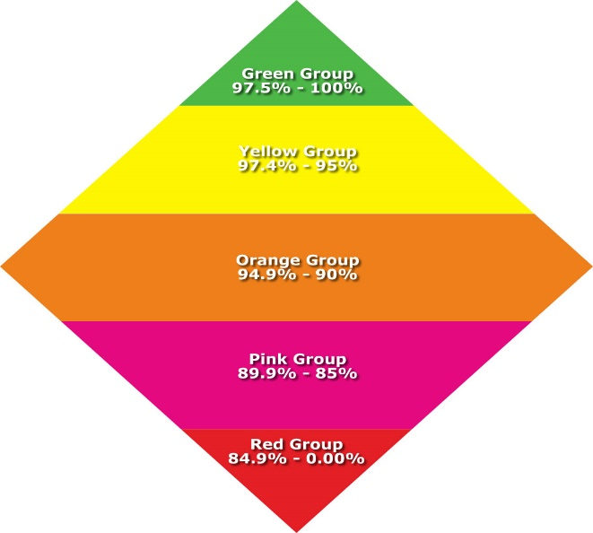

Taking the Register
Registration is from 8.45am to 9.00am each morning. Any child arriving after 9.00am is categorised as “Late”. Children who are late are recorded in the Late Register. This is monitored by The Attendance Lead, Mrs Tite. Any children identified during a week (5 days) who have been recorded as late will be sent a ‘late letter’. This is monitored throughout the week to see improvements and noted on the school’s Headline figures. These figures highlight the start date and end date of any late period to show impact. If there has been no improvement for a particular family, lateness will be followed up with conversations and noted on the Headline figures However, if there is no improvement after three weeks of monitoring Mrs Tite will arrange a meeting with Ms Gosal the Headteacher to discuss this and support that can be offered.

Children who arrive after 9.15am are classified as “U’ – after the register is closed” and receive an “Unauthorised Absence”, unless school has been notified in advance that they may be late for a special reason e.g. a medical or dental appointment. This is then marked as a ‘M’ upon receipt of evidence for the appointment being provided.

Persistent Lateness
This will be monitored by Mrs Tite and will be noted through Headline Figures, personal conversation and progress being made with follow up calls.

Registration and Lateness
The Class Attendance Register is a legal document and must be completed at the beginning of the morning and afternoon sessions each day.

Our school uses “SIMS” for marking children’s attendance. A paper copy of the “SIMS register is kept in the class register folder, a copy of these registers is also printed and kept in the office, in case of an emergency evacuation e.g. fire drill or ‘SIMS’ failure.

Reporting absence
The School Prospectus sets out the procedure for parents to follow in the case of a child’s absence. Absence should be reported immediately to school by the Parent or Carer. This may be by a telephone call, a written note or by personal contact. The reason for absence and a possible date for return must be provided. This information is passed to the Administrative Assistant’s for processing. First day absence where there has been no notification is followed up by Mrs Tite, Lead Attendance Person. A telephone call is made, and a Class Dojo message is sent to the parent’s mobile telephone asking them to contact the school and provide a reason for their child’s absence. Where it has not been possible to confirm the reason for absence on the first day, parents are required to inform school in writing on the child’s return. If no reason is received this will then be followed up with an Attendance Letter and parents are requested to respond via the reply slip providing a reason for their absence. This letter explains that if no reason is given, this will be recorded on the register as an ‘O’ code – unauthorised.

Attendance Impact

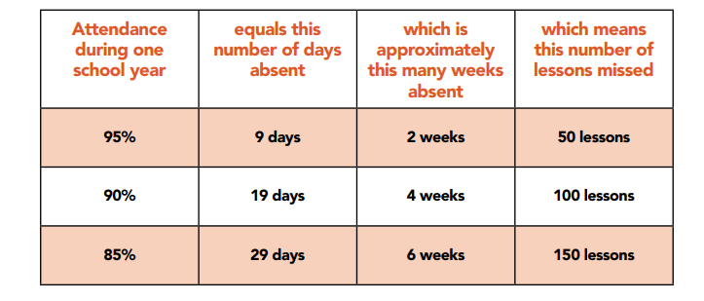

Early Help
We adopt early help practice ensuring that we can support children and families in the most supportive and holistic way.

▪ ‘Working together to improve school attendance’ recognises that effective early help relies upon local agencies working together to identify children and families who would benefit from support. Undertaking an early help assessment and providing targeted services to address these needs to significantly improve outcomes for these families.
▪ All agencies have a responsibility to deliver early help in line with Birmingham Safeguarding Children Partnership’s (BSCP) agreed Layers of Need as set out in ‘Right Help, Right Time’ and consistent with Birmingham’s Early Help Strategy.
▪ A holistic approach to early help must include capturing the voice of the child, otherwise an assessment would be incomplete and could be missing information vital to supporting the family or even safeguarding the child.

Support First Framework



Referrals to the Court Section of the Education Welfare Service
The following criteria will trigger a referral by the Lead Attendance Person and the Headteacher who will refer the matter to the Legal Intervention Team.
- Children with more than 20 sessions authorised absence in a year (illnesses, after referral for support is given i.e. School Nurse, Early Help and illness letter sent out).
- Children with more than 10 sessions unauthorised absence in a year will become part of the action group and the Education Welfare Office (EWO) will be notified.

The Headteacher will be advised and guided by the Lead Attendance Person and the Headteacher will consider whether to stop authorising absences for these categories unless there is medical evidence.

The Lead Attendance Person and the DSL’s will monitor vulnerable pupils and consider whether the family is to be referred to the Integrated Family Support Team (IFST) or to follow the legal process. Reasons for absence are checked and verified, and ‘Early Help Process’ is considered. If there are additional concerns the Lead Attendance Person will discuss these at Safeguarding Meetings to ensure early help and other strategies and support can be offered.

The Local Authority has statutory powers to issue Penalty Notices which may lead to prosecution. Each year the school will run a ‘Spotlight on Attendance’ campaign with the support of the court section of the Education Welfare Service. If attendance does not improve after meetings with parents, the court section of the Education Welfare Service will issue Penalty Notices. In the case of fines not being paid, this may lead to prosecution. The LAP is required to support the Local Authority in preparing the cases and the Headteacher has responsibility for issuing accurate attendance certificates.

Legal outcomes in respect of poor attendance
Section 23(1) Anti-Social Behaviour Act 2007: Penalty notices may be issued to the parent of pupils who have unauthorised absence from school for first offences. For second offences the discount of £80 will not apply. (In cases of excessive absence, or for a third or more offence, whether for ongoing absence or leave in term time, the matter may be referred straight to Court)

• The amount of the penalty is £80.
• If this is not paid within 21 days the amount rises to £160.
• If not paid within 28 days the Local Authority may prosecute under section 444(1) unless it comes to our attention that the penalty notice had been issued in error.

Section 444(1) Education Act 1996: “If you are the parent of a child of compulsory school age who fails to attend school regularly, you are guilty of an offence.” The court can fine each parent up to £1,000 per child, order payment of the prosecution costs, impose a victim surcharge, and/or make a Parenting Order.
Section 444(1A) Education Act 1996: “If in the above circumstances you, the parent, know that your child is failing to attend regularly at the school and fail without reasonable justification to cause him/her to attend, you are guilty of an offence.” The court can fine you up to £2,500 per child and/or sentence you to a period of imprisonment of up to 3 months, impose a victim surcharge and order payment of the prosecution costs

Removing children from the register
Children may only be removed from the school’s roll by the Lead Attendance Person on receipt of confirmation of enrolment from the receiving school and with authorisation from the Headteacher. No child will be removed off roll without full investigations being carried out, guidance being given by CME and LSNT (children Missing Education/Left School No Trace) and confirmation of outcome being received from them. Where possible early intervention will take place and evidence of movement will be recorded and passed on to the Local Authority. School Movement is monitored and input on to The Impulse portal by the LAP
Categories of Absence:
Categories of absence are decided by the Local Authority. Absence is authorised when it is demonstrated that:

1. The child was absent with permission from School for special circumstances,
e.g. for a medical or dental appointment or a funeral. This is recorded as a ‘C’ Code
2. The child was ill is recorded as a ‘i’ Code
3. The child was observing a religious festival is recorded as a ‘R’ Code
4. The child was being educated at another educational location is recorded as a ‘B’ Code
5. The child is attending an approved enrichment activity e.g. musical, sporting is recorded as a ‘P’ Code
6. The child is on an educational visit is recorded as a ‘V’ Code

Absence is not authorised for shopping, birthdays, days out or holidays in term time. These are all classified as Unauthorised Absences.

Appointments
  - As far as possible, parents should attempt to book medical and dental appointments outside of school hours.
  - Where this is not possible, the school may ask to see some form of evidence such as an appointment card or hospital letter.
  - If the appointment requires the pupil to leave during the school day, they will need to be signed out at the school office by a parent.
  - Pupils should attend school before and after the appointment wherever possible.

Authorisation of Holidays
Whilst the Governors are sympathetic to parents who wish to take their child/children on holiday during term time, within the government’s directives, we are unable to authorise such absence. The Lead Attendance Person and Office Staff are encouraged to advise according to the Local Authority’s Advice. They will recommend that a holiday form is completed and advise that the Headteacher will not authorise any holidays however will be notified of suggestions. that could be offered.

Roles and Responsibilities

Governors
Governors monitor the percentage of attendance and respond to the section of the Headteacher’s report at the full governing body meetings.

Headteacher
The Headteacher reports the rates of attendance each term to the Governing Body. The Headteacher outlines any actions taken to meet the school target and support that has been offered. Referrals are made to the court section of the Education Welfare Service children and families that have poor attendance.

The Attendance Lead Person
The Lead Attendance Person is responsible for regularly checking attendance data and ensuring data is accurate and up to date.

The Lead Attendance Person will:
• Ensure that data is input daily into the attendance management system
• Ensure that parents of absent children are contacted where notification of absence has not been received
• Respond to any parent seeking support on attendance concerns
• Provide regular attendance and punctuality data for relevant staff and external agencies in line with the agreed procedures and timescales
• Be responsible for disseminating important attendance information including informing the Attendance Leader of which children are of concern; in-line with the agreed procedures and timescales
• Be responsible for keeping a record of the interventions in place to encourage attendance and for generating all documentation including letters to parents
• Be responsible for liaising closely with the Local Authority’s Attendance Team to ensure appropriate levels of intervention take place; referrals are made, and attendance meetings are set up
• Be responsible for managing and maintaining attendance records and system

Children
Children are expected to achieve high rates of attendance and punctuality and are supported by all stakeholders in this expected outcome.

Teachers
It is the responsibility of teachers to register pupils. Notes about absences are collected and stored in the front of the Class Information Register. Concerns about absences are reported through CPoms alerting the Lead Attendance Person. This includes children of concern where these are discussed with parents at parents’ evening. During tutor time to ensure house points are given according to Attendance Tracker information and personal conversations recorded on the tracker.

Teaching Assistants
Teaching Assistants support the teacher in the registration/CPoms and House Points/ Attendance Awards of pupils they are working with. They are expected to liaise with teachers to report children with attendance concerns to Senior Clerical Assistant and DLP

Office Team
Providing information to the Lead Attendance Person to assist with Attendance Progress and support. The role of the Lead Attendance Person is crucial in monitoring attendance and punctuality and being front of house to receive children and ask appropriate questions relating to absence and tardiness. They will provide guidance and advice and provide any vital next steps that need to take place. The Lead Attendance Person is also the first point of contact with the Local Authority Teams and providing the necessary direction to the Headteacher in line with their guidance, policies and procedures.

Equal Opportunities
This policy and guidelines promote the practice of inclusion for all.

Legal Definitions
‘Parent’ - Education Act 1996
▪ A ‘parent’ in relation to any child or young person, includes any person: -
o who is not a parent but who has parental responsibility for the child, or
o who has care of the child.

▪ This also includes absent parents who must have regular contact and an ability to influence the child, including his/her attendance. Parental partners should be included (whether they are married or the natural parent of the child) as they have ‘care of’ the child. If a pupil lives with a grandparent or older sibling as their main carer they can also be included.

