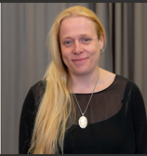
About the Oracy Leader
Our Oracy Leader, who is also the Deputy Headteacher, is a member of the Central Maths Hub Leadership and Management Team. This year, she was successfully appointed as the Oracy Equity Lead for the Maths Hub.
Equity Leads are key members of the Maths Hub team, responsible for developing the hub’s community of Local Leaders of Mathematics Education (LLMEs). Their aim is to promote greater equity in maths education across all phases in schools and colleges throughout the hub area, which includes Birmingham, Sandwell, and Dudley. This work is both complex and system-changing in nature.
Sharing Our Practice
In addition to her role as Oracy Equity Lead, our Deputy Headteacher also serves as an Assistant Maths Hub Lead and is a Cohort One Primary Mastery Specialist. As a result, we are proud to regularly welcome colleagues from across Birmingham, Sandwell, Dudley, and beyond to observe and engage with our approach to teaching and learning in mathematics.
In 2024–2025, we hosted 22 Open Lessons, each involving between one and five classrooms. Each of these sessions welcomed between 8 and 25 visiting teachers, offering them the opportunity to see Teaching for Mastery in action.
Over the past year, we’ve also seen growing interest in how we are developing Oracy across the curriculum, with many schools keen to explore how we use oracy to deepen mathematical understanding.

Year 5 - 9th October: Primary Mastery Specialists and Local Leaders of Maths Education:
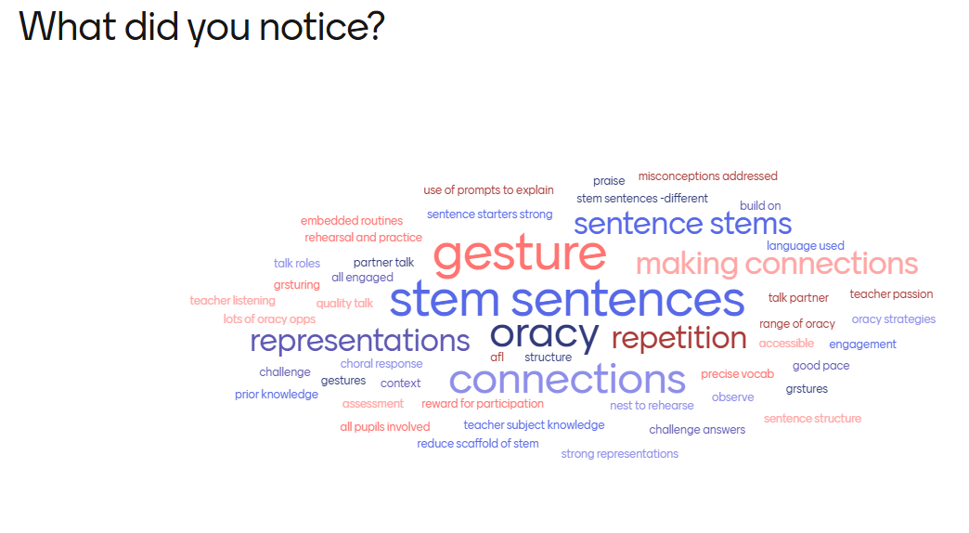

Year 3 - 3rd October 2025 – Introduction to Teaching for Mastery:
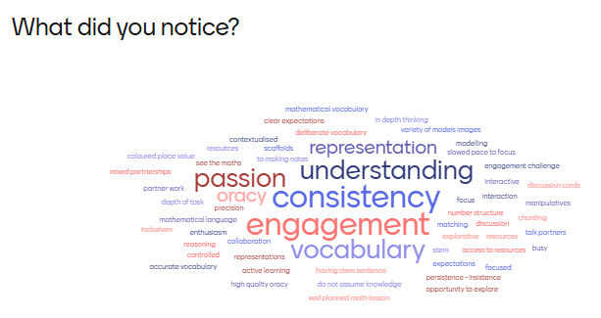

Year 4 - June 2025:
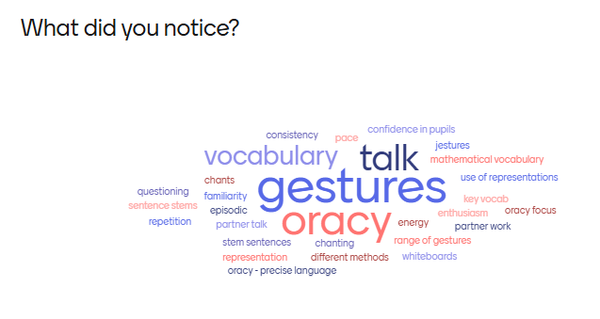

Year 5 June 2025:
