Research and Publications that we are learning from:
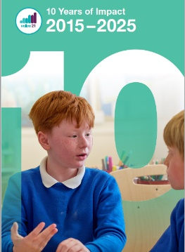 | 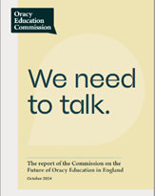 | 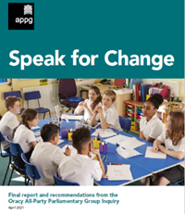 | 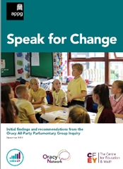
Voice 21 – 10 years of Impact (June 2025) pdf | ‘We need to talk’, The Report on the Commission on the Future of Oracy Education | Oracy APPG (All Party Parliamentary Group) (April 2021) Report: Speak for Change | Oracy APPG Interim Report: (December 2020): Speak for Change Inquiry
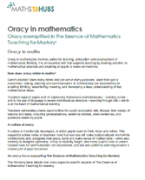 | 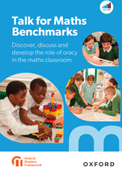 | 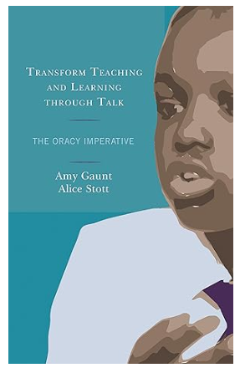 | 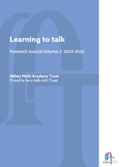
NCETM Oracy in Mathematics Framework (2025) | Oxford University Press (OUP) Talk for Maths Benchmarks (2024) | Transform Teaching and Learning Through Talk. The Oracy Imperative.  Amy Guant & Alice Scott | Abbey MAT Oracy Research Journal 2024-2025: Learning to Talk
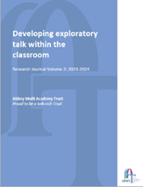 | 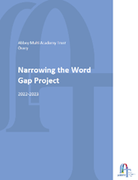 | 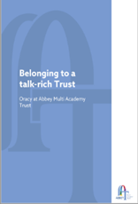
Abbey MAT Oracy Research Journal 2024-2023: Developing Exploratory Talk Within Classroom | Abbey MAT Oracy Research Journal 2023-2025: Narrowing the word gap | Belonging to an Oracy-rich Trust – Oracy at the Abbey MAT

