
Fluency at World’s End Junior School
Why have fluency lessons?
Mathematical fluency is the foundation for success in problem-solving and reasoning. It ensures that pupils can:
- Work efficiently and accurately with basic number facts and procedures.
- Free up cognitive load: When core skills are automatic, pupils can focus on higher-order thinking rather than basic calculations.
- Apply knowledge flexibly: Fluency supports transfer of skills across contexts, enabling pupils to tackle unfamiliar problems with confidence.
- Build confidence and resilience: Secure fluency reduces anxiety and promotes a positive attitude towards mathematics.
Without fluency, pupils often struggle with reasoning and problem-solving because too much mental energy is spent on recalling facts or performing simple operations. This aligns with research on working memory and automaticity, which shows that procedural fluency underpins conceptual understanding.
What is taught in a fluency lesson?
Fluency lessons develop both procedural fluency and conceptual understanding, as outlined in the National Curriculum.
- Procedural fluency ensures pupils can carry out calculations accurately and efficiently.
- Conceptual understanding gives meaning to these procedures and enables flexible application.
Together, these elements underpin mathematical proficiency. Therefore, fluency lessons always include both how to perform mathematical operations and why the underlying concepts work, so pupils can apply their knowledge confidently in reasoning and problem-solving.
What if students struggle to make progress?
When pupils find it difficult to make progress, they should be supported promptly within lessons by the class teacher through targeted questioning and scaffolding. If further support is needed, a range of strategies can be implemented, such as:
- Focused interventions with a teacher or teaching assistant to address specific gaps.
- Additional practice at home, including tailored homework tasks.
- Digital resources such as Mathletics and Times Tables Rockstars to reinforce key skills.
- Monitoring and review to ensure interventions are effective and progress is tracked.
The aim is to provide timely, personalised support so that all pupils can develop secure fluency and confidence in mathematics.
When are the fluency lessons and how are they monitored?
Fluency lessons are typically scheduled straight after lunch, unless otherwise indicated on the class timetable. These sessions are regularly monitored by the Maths Team and members of the school leadership to ensure consistency and quality.
In addition, the use of online practice platforms such as Mathletics and Times Tables Rockstars is routinely monitored by the teacher to confirm that pupils are engaging with the resources and making expected progress. Monitoring outcomes are used to inform planning and provide targeted support where needed. These platforms are also monitored by the Second Leader in Mathematics to ensure consistency in use by all teachers.
Overview for each year group
Year 3
Teaching
In Year 3, the primary focus is on additive relationships. These are taught through the Year 3 Mastering Number programme. It is expected that the Teaching for Mastery and Oracy approaches used in daily maths lessons are consistently applied during fluency sessions.
Fluency is taught in blocks, and teachers use end-of-block assessments and fact sheets to identify which blocks will most benefit their class throughout the year. Within these sessions, additive patterns, structures, and connections are taught explicitly alongside procedural methods to ensure pupils develop a strong conceptual understanding as well as efficient strategies.
Practise
Fluency practice is supported through engaging digital platforms:
- NumBots
Linked to the addition and subtraction facts taught in Mastering Number, NumBots allows children to progress through a structured “number story.” Progress is celebrated in class, with results displayed on a classroom number story and stickers awarded for milestones.
- Times Tables Rockstars
Once pupils are secure with additive facts, they transition to Times Tables Rockstars to develop multiplication and division fluency. A whole-class fluency chart is displayed, and progress is recorded and rewarded to motivate continued improvement.
These platforms provide regular, purposeful practice that reinforces classroom learning and builds automaticity in key number facts.
- Mathletics
Tasks are set linked to any gaps in knowledge and understanding identified in Maths lessons.
Assessment
At the end of each term children complete 2 facts sheets (addition, number bonds to 5, 10, addition crossing the 10s boundary).
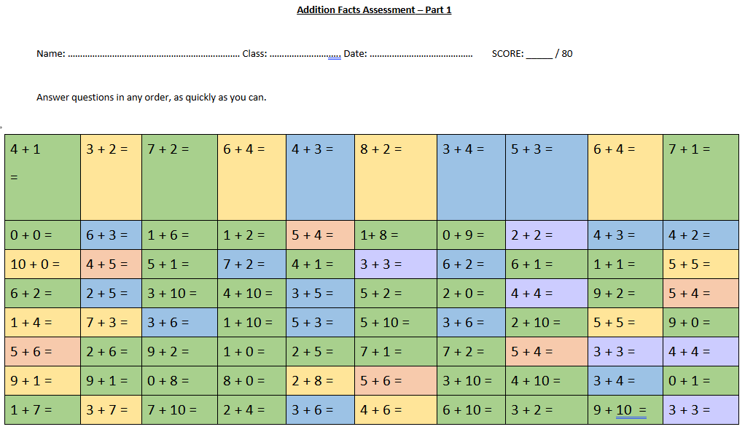

Example of sheet 1

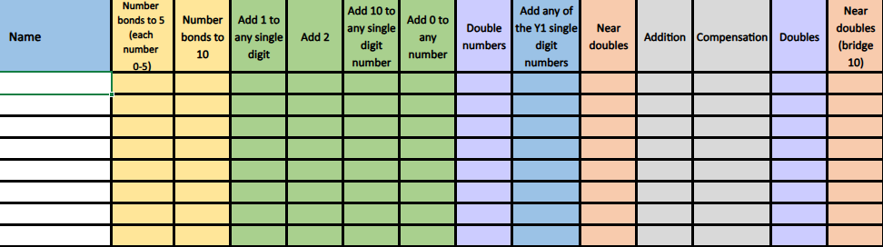

Example of assessment spreadsheet
During fluency assessments, teachers monitor not only accuracy but also how pupils complete tasks. Indicators such as counting on fingers or taking longer than three seconds to recall facts help identify pupils who need additional support.
- Recording Support
Teachers may scribe for pupils who have difficulty writing answers, ensuring that recording does not hinder progress in fluency.
- Intervention for Gaps
Any pupil struggling to recall number facts should be flagged on the assessment spreadsheet and provided with extra intervention. This may include:
  - Targeted support from the teacher or teaching assistant.
  - Additional homework focused on identified gaps.
- Progress Criteria
Pupils achieving 140/160 or above are considered to be working at the expected standard and can progress to the next stage of learning number facts.
Progressing to multiplication
By the Summer term, the majority of pupils are ready to progress from additive facts to learning their multiplication facts. The concept of multiplication is introduced and taught explicitly during daily maths lessons, ensuring pupils understand the underlying structure before focusing on recall.
Fluency practice for times tables is then supported through Times Tables Rockstars, providing engaging, regular opportunities for pupils to consolidate and automate these facts.
Year 4
Teaching
In Year 4, the focus shifts to multiplicative relationships, taught through the Year 4 Mastering Number programme. As with other year groups, the Teaching for Mastery and Oracy approaches used in daily maths lessons are expected to be consistently applied during fluency sessions.
During the Spring Term, the Going for Gold initiative is introduced. Pupils practise recalling the core 36 multiplication facts using their own set of revision cards, stored in a small bag for easy access. Progress is celebrated through the Going for Gold display in the classroom, recognising both individual and class achievements.
Fluency is taught in blocks, with an assessment at the end of each block. These assessments inform intervention groups and identify pupils who require additional support, ensuring that all learners develop secure multiplicative fluency.
Practise
Fluency practice in Year 4 is supported through two key platforms:
- Times Tables Rockstars (TTRS)
Pupils are given regular opportunities in class and for homework to engage with various game modes, earning points and improving recall speed. The platform automatically identifies which multiplication facts require further practice and sets personalised challenges.
To increase engagement, class tournaments are organised. Progress is monitored and celebrated through praise and recognition.
- Mathletics
Tasks are set to address gaps in knowledge and understanding identified during maths lessons. These activities provide targeted reinforcement and help pupils consolidate core concepts.
Both platforms are used to ensure pupils receive consistent, purposeful practice that supports fluency development and builds confidence.
Assessment
At the start of the year, and at the end of each term, pupils complete a Times Tables Rockstars (TTRS) baseline assessment. Scores are recorded on the platform and tracked throughout the year to monitor progress.
Children regularly engage with TTRS game modes such as Soundcheck, which generate individual and whole-class heat maps. These heat maps show which multiplication facts pupils are secure with and where further practice is needed. Data is then broken down into a fluency table, indicating the average response time for each fact.
Teachers download individual heat maps to monitor progress and plan targeted interventions, ensuring that all pupils develop rapid and accurate recall of multiplication facts.
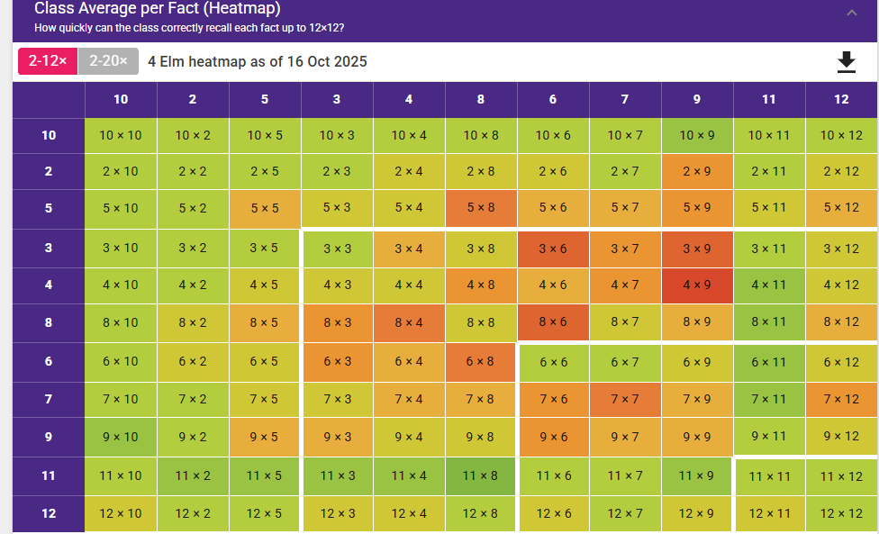

Whole class heat map

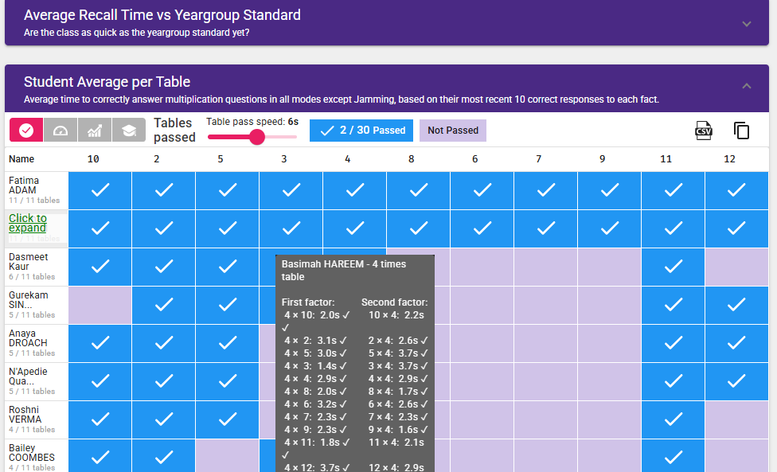

Whole class fluency table

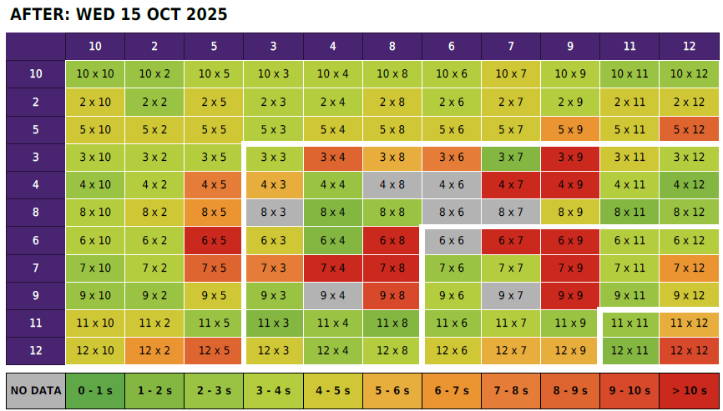

Individual heat map

Throughout the year, Times Tables Rockstars (TTRS) offers opportunities for pupils to take part in unofficial multiplication checks. These replicate the statutory Multiplication Tables Check that pupils complete in the Summer term. The data collected is used to identify pupils who require additional support.
For children struggling to achieve fluency in times tables, the following strategies are implemented:
- Identify the specific gap (which number fact is causing difficulty).
- Targeted intervention with the class teacher.
- Small-group support with a teaching assistant.
- Additional homework focused on the identified facts.
- Parent engagement through conversations and guidance for home practice.
- Certificates and incentives to celebrate progress.
- High profile of TTRS in school to maintain motivation.
- Fun classroom challenges to encourage participation and enjoyment.
These approaches ensure that pupils receive timely, personalised support and remain motivated to achieve fluency.
Year 5
Teaching
In Year 5, the focus is on deepening understanding of multiplicative thinking, taught through the Year 5 Mastering Number programme. As in previous years, the Teaching for Mastery and Oracy approaches used in daily maths lessons are expected to be consistently applied during fluency sessions.
Fluency is taught in blocks, with an assessment at the end of each block to identify gaps and inform intervention groups or additional support.
Each half term also includes a focus on Key Instant Recall Facts (KIRFs). These are introduced in class, practised throughout the half term, and sent home as fluency homework to reinforce learning.
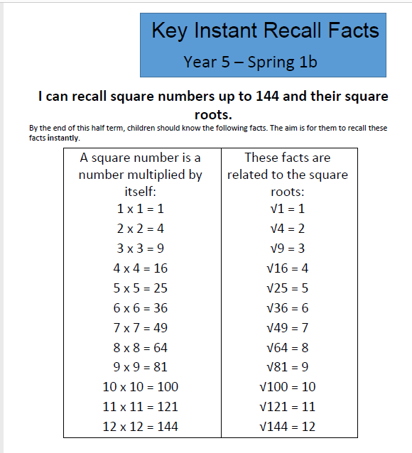

Example of Key Instant Recall Facts Spring Term.

Practise
Fluency practice in Year 5 continues to be supported through:
- Times Tables Rockstars (TTRS)
Pupils are given regular opportunities in class and for homework to engage with various game modes, earning points and improving recall speed. The platform automatically identifies which multiplication facts require further practice and sets personalised challenges accordingly.
- Mathletics
Tasks are assigned to reinforce concepts taught in maths lessons and address any gaps identified through assessment (see end of policy for details).
These platforms provide structured, engaging practice that complements classroom teaching and supports pupils in achieving fluency with multiplicative facts.
Assessment
Key Instant Recall Facts (KIRFs) are assessed at the end of each half term. Pupils are tested on the relevant set of facts, and a score of 16/20 or above indicates that they are meeting age-related expectations and can progress to the next set of key facts.
Children who do not meet the expected standard should be recorded on the assessment spreadsheet and provided with additional support. This may include:
- Targeted intervention with the teacher or teaching assistant.
- Extra homework focused on the specific facts that need reinforcement.
Regular assessment ensures that gaps are identified promptly and addressed through personalised intervention, supporting all pupils to achieve fluency.
Year 6
Teaching
A Year 6 fluency session is divided into three sections:
- Recall
Pupils complete calculations and answer questions using knowledge from previous year groups to maintain and strengthen core fluency skills.
- Application to Arithmetic
Pupils apply their fluency knowledge to questions similar to those found in Paper 1: Arithmetic of the SATs papers, developing speed and accuracy under test conditions.
- Reasoning and Problem-Solving
Pupils use their fluency skills to tackle a variety of reasoning problems, promoting deeper understanding and flexible application.
After each section, teachers model solutions using pupils’ work, ensuring misconceptions are addressed and providing opportunities for detailed explanations. This approach reinforces conceptual understanding alongside procedural fluency.
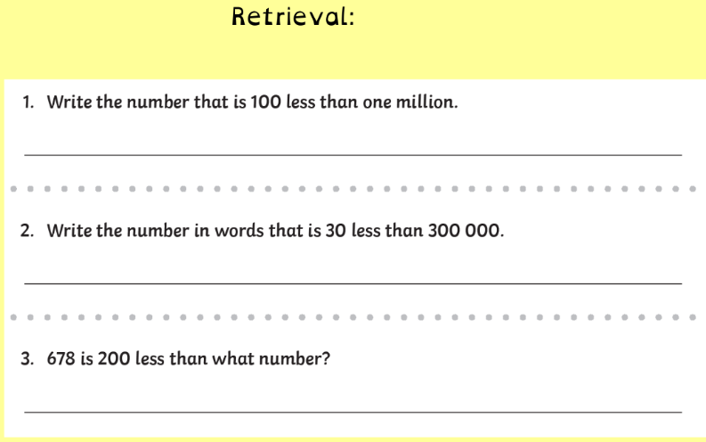
Example of section 1

Example of section 2

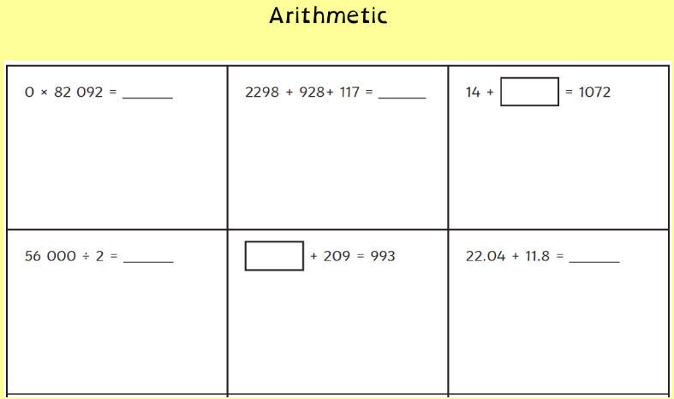
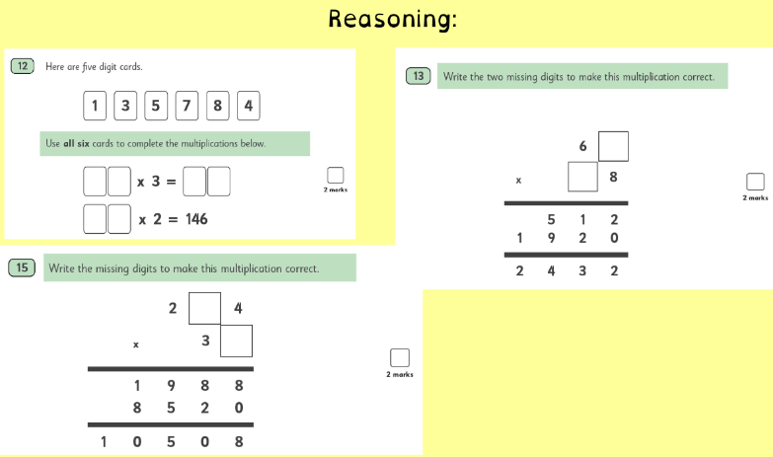

Example of section 3

Practise
Fluency practice in Year 6 is supported through:
- Times Tables Rockstars (TTRS)
Pupils engage with various game modes to earn points and improve recall speed. TTRS automatically identifies which multiplication facts require further practice and sets personalised challenges accordingly. The platform also ensures pupils practise related division facts.
- Mathletics
Tasks are assigned to reinforce concepts taught in maths lessons and address gaps identified through assessment.
These platforms provide structured, engaging practice that complements classroom teaching and supports pupils in achieving fluency with multiplication and division facts.
Assessment
Regular assessment during lessons and after completing different maths challenges informs the content for Maths Workout sessions. These sessions target gaps identified through ongoing monitoring.
Each fortnight, pupils also complete an arithmetic test. Targeted questions from these tests are explicitly taught to ensure pupils develop both conceptual understanding and procedural fluency. Teachers work through parts of the test with pupils, providing timely feedback and opportunities to correct mistakes.
Assessment outcomes are used to identify pupils who need extra support. This may include:
- Targeted intervention with the teacher or teaching assistant.
- Additional homework focused on specific gaps.
- Attendance at booster classes after school, which are offered to pupils based on regular assessment data and teacher judgment.
This structured approach ensures pupils are well-prepared for SATs and confident in applying their fluency skills across all areas of mathematics.
Mathletics
The majority of children complete Mathletics tasks specifically assigned to address gaps in learning/deepen their learning.
Monitoring and Keep Up
Maths Keep-Up Books are completed daily as a record of teacher-led interventions and pupil participation. These books include:
- Notes on the specific activities completed.
- Observations of areas where pupils struggled, including insights from Mathletics tasks.
Mathletics automatically tracks all completed work, providing a clear record of engagement and progress. Pupils who are flagged as ‘red’ or have not completed sufficient tasks are identified for additional support. Strategies to address this include:
- Targeted interventions during fluency sessions.
- Pupil conferencing to discuss barriers and set goals.
- Extra homework focused on identified gaps.
This process ensures that pupils receive timely, personalised support to close gaps and maintain progress toward fluency goals.
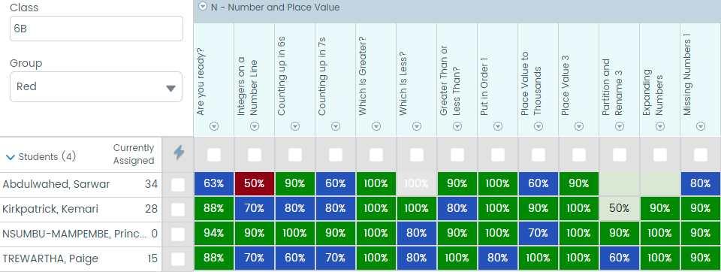
Example of children’s progress against tasks on Mathletics

