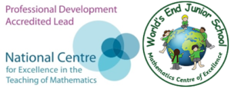
About the maths leader

Deputy Headteacher with Responsibility for Mathematics
Ms Craddock holds a number of significant roles within the Central Maths Hub and beyond:
- Assistant Maths Hub Lead, Central Maths Hub
- Oracy Equity Lead, Central Maths Hub
- MA in Specialist Primary Mathematics (Edge Hill University)
- NCETM Mastery Specialist (Cohort 1 & England–China Exchange Programme, 2016–2017)
- NCETM-accredited Professional Development Lead and Programme Facilitator
- NCETM Intensive Support Partner and Enhanced Support Partner
- Maths — No Problem! Master Trainer
With these quality marks and leadership roles, Ms Craddock supports teachers, maths subject leaders, and senior leaders from schools across Birmingham, Sandwell, Dudley, and beyond. Examples of this work include:
- Oracy Equity Lead – supporting Local Leaders of Maths Education across all phases of education in developing Oracy in their schools
- Teaching for Mastery Lead, Central Maths Hub – supporting and coordinating a team of 14 Teaching for Mastery Specialists
- Active Teaching for Mastery Specialist – leading Introduction to Teaching for Mastery and Teaching for Mastery Work Groups
- Facilitating the NCETM PD Lead Programme
- Delivering the NCETM Specialist Knowledge for Teaching Mathematics programmes for teachers, ECTs, and teaching assistants
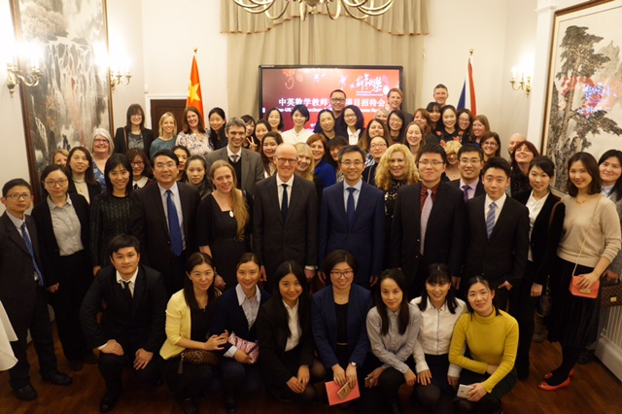
- Providing bespoke CPD, including teacher development days and twilight sessions – as far afield as Jersey and Sussex

