

**Behaviour Policy**

**Policy Date:**

**Next review: End of Spring 2 2024**

**Purpose**

A calm, safe learning environment is essential if pupils are to learn most effectively. It is the responsibility of the school to provide that environment so that pupils and teachers can make most use of lesson time for the real purpose of education. This policy aims to promote positive behaviour for learning and how we aim to achieve this at World’s End Junior School. Our behaviour policy is underpinned by our three school values: Respect, Readiness and Resilience and our training as a TIASS school (Trauma Informed Awareness School).

At Worlds End Junior School we believe that every behaviour communicates a need, and we strive to support every pupil based on their individual needs. Teaching and learning remain at the heart of our school community where we expect positive behaviour for learning to ensure that all pupils can learn and reach their full potential. Everyone should treat one another with dignity, kindness and respect.

This policy is based on legislation and advice from the Department for Education (DfE) on:

[Behaviour and discipline in schools: advice for headteachers and school staff, 2016](https://www.gov.uk/government/publications/behaviour-in-schools--2)

[Behaviour in schools: advice for headteachers and school staff 2022](https://www.gov.uk/government/publications/behaviour-in-schools--2)

[Searching, screening and confiscation at school 2018](https://www.gov.uk/government/publications/searching-screening-and-confiscation)

[Searching, screening and confiscation: advice for schools 2022](https://www.gov.uk/government/publications/searching-screening-and-confiscation)

[The Equality Act 2010](https://www.gov.uk/government/publications/equality-act-2010-advice-for-schools)

[Keeping Pupils Safe in Education](https://www.gov.uk/government/publications/keeping-children-safe-in-education--2)

[Exclusion from maintained schools, academies and pupil referral units in England 2017](https://www.gov.uk/government/publications/school-exclusion#:~:text=Schools%20and%20colleges%20must%20continue,headteachers)

[Suspension and permanent exclusion from maintained schools, academies and pupil referral units in England, including pupil movement - 2022](https://www.gov.uk/government/publications/school-exclusion#:~:text=Schools%20and%20colleges%20must%20continue,headteachers)

[Use of reasonable force in schools](https://www.gov.uk/government/publications/use-of-reasonable-force-in-schools)

[Supporting pupils with medical conditions at school](https://www.gov.uk/government/publications/supporting-pupils-at-school-with-medical-conditions--3)

[DfE guidance](https://www.gov.uk/guidance/what-maintained-schools-must-publish-online#behaviour-policy) explaining that maintained schools must publish their behaviour policy online

It is also based on the [Special Educational Needs and Disability (SEND) Code of Practice](https://www.gov.uk/government/publications/send-code-of-practice-0-to-25).

# Policy Links

The behaviour policy also links to

* Exclusions policy
* Child protection and safeguarding policy
* Anti-bullying policy
* Accessibility policy
* SEN policy and school information repot
* Mental Health offer
* Equality Statement
* Pastoral Information Report

**Table of Contents**

Policy Links 2

Our Vision 3

Safeguarding 4

School Leaders: 4

The governing body: 4

Staff: 4

Parents and carers: 5

Pupils: 5

Responding to behaviour 5

Responding to positive behaviour 5

Responding to negative behaviours 6

Adapting sanctions for pupils with SEND 9

Pupils with an education, health and care (EHC) plan 9

Off-site misbehaviour 9

Online misbehaviour 9

Suspected criminal behaviour 9

Malicious allegations 10

Sexual harassment and violence 10

Zero-tolerance approach to sexual harassment and sexual violence 11

Child-on-child abuse 11

Bullying 12

Bullying 13

Types of bullying 13

Confiscation, searches, screening 13

Confiscation 13

Prohibited items: 13

Searching a pupil and their possessions 14

Team Teach – Restraint 14

Transition of pupils 14

Pupil Transition 14

Preparing outgoing pupils for transition 14

Appendix 1: ClassDojo and communication 14

ClassDojo and House Points 15

Appendix 2: Playtime and Lunchtime Procedures 15

More Serious Behaviour Incidents 16

Appendix 4: Behaviour for Learning 17

Zone Diaries and Trackers 17

Appendix 4a: Zone Diary example 17

Appendix 4b: Example tracker 17

# Our Vision

We have high aspirations and expectations for every child to leave World’s End Junior School with the knowledge, skills and experiences to make positive life choices, to build healthy relationships and to find their place in the world as happy and successful citizens.

We believe that responsible behaviour underpins and facilitates good progress and high standards of achievement. Teaching staff, support staff, parents and governors are all responsible for and can influence the behaviour of pupils.

Safeguarding

The school recognises that changes in behaviour may be an indicator that a pupil needs help or protection.

We will consider whether a pupil’s misbehaviour may be linked to them suffering or being likely to suffer significant harm.

Where this may be the case, we will follow our child protection and safeguarding policy, and consider whether pastoral support; an early help intervention or a referral to children’s social care is appropriate.

Please refer to our child protection and safeguarding policy for more information

**Leadership and Management**

School Leaders:

Leaders (Headteacher, Deputy headteacher(s), Pastoral Lead, SENCo, Pastoral Manager, Phase Leaders) are responsible for:

* Training staff
* Ensuring that staff have adequate training on matters such as how certain special educational needs, disabilities, or mental health needs may at times affect a pupil’s behaviour
* Sharing the behaviour policy
* Publishing the behaviour policy
* Communicating the policy to all members of the school community
* Monitoring the implementation of the behaviour policy
* publicise the school behaviour policy in writing to parents, staff, and pupils at least once a year
* Induction of new staff and agency workers
* School Leaders will support staff in responding to behaviour incidents
* Consultation with governors to review and monitor policies
* Record data, analyse for trends and evaluate the effectiveness of the policy
* Report data to the Full Governing Body on a half-termly basis

The governing body:

* Monitoring the policy’s effectiveness
* Holding the headteacher to account for its implementation

Staff:

* Creating a calm and safe environment for pupils
* Establishing and maintaining clear boundaries of acceptable pupil behaviour
* Implementing the behaviour policy consistently
* Communicating the school’s expectations, routines, values and standards through teaching behaviour and in every interaction with pupils
* Modelling expected behaviour and positive relationships
* Providing a personalised approach to the specific behavioural needs of particular pupils
* Considering their own behaviour on the school culture and how they can uphold school rules and expectations
* Recording behaviour incidents promptly
* Challenging pupils to meet the school’s expectations
* Listen and value pupils’ voice and acting upon this

Parents and carers:

* Get to know the school’s behaviour policy and reinforce it at home where appropriate
* Support their child in adhering to the school’s behaviour policy
* Inform the school of any changes in circumstances that may affect their child’s behaviour
* Discuss any behavioural concerns with the class teacher promptly
* Take part in any pastoral work following misbehaviour (for example: attending reviews of specific behaviour interventions)
* Raise any concerns about the management of behaviour with the school directly, whilst continuing to work in partnership with the school
* Take part in the life of the school and its culture

Pupils:

* That they have a duty to follow the behaviour policy and school values

# Responding to behaviour

## Responding to positive behaviour

Each classroom displays the school values and teachers refer to them throughout the day.

At the start of each year, behaviour expectations, sanctions and rewards are shared or revisited with pupils. This is then revisited on a regular basis.

Examples of rewards may include:

* Verbal praise;
* Communicating praise to parents via phone call, dojo (appendix 1) or written correspondence;
* Star of the week certificates, Gold Book Assemblies, House Points;
* Positions of responsibility such as JLT, Lunchtime Monitor, UNICEF, House captains
* Whole-class or year group rewards, such as a popular activity
* “Catch Me” sheet
* Extra reward time

Responding to negative behaviours

We recognise that praise is more efficient than sanctions nevertheless the school will take a firm stand on negative behaviours including bullying and racist behaviour. We do not tolerate behaviour that interrupts learning in anyway. School staff will deal with incidents in their manner and style appropriate to the level of disruptive behaviour involving schools' leaders as appropriate.

At World’s End Junior School, we follow a consequences system to ensure minimal disruption to teaching and learning.

The decision to suspend or exclude will be made by the headteacher and only as a last resort.

Following any suspensions, a reintegration meeting will be held with the pupil, parents and where necessary other agencies. During this meeting school will consider what support is needed to help the pupil to return to mainstream education and meet the expected standards of behaviour. This will be recorded on CPOMS (Child Protection Online Management System).

**CONSEQUENCE SYSTEM**

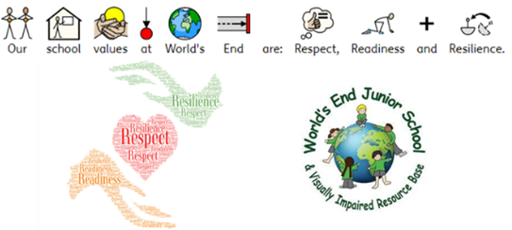

|  |  |  |
| --- | --- | --- |
| Sanction | Description | Additional information |
| Verbal | Verbal reminder | A reminder of expected behaviour with strategies to support and self-regulate. Change of seat or brain break offered if appropriate. |
| C5 | 5 minutes in the hub during break or lunch  *Teacher/TA to support pupil with de-escalations strategies* | Restorative conversation |
| C10 | 10 minutes in the hub during break or lunch  *If behaviour continues whilst on a C10 TA/teacher/pastoral to have a conversation with child to de-escalate.* | Restorative conversation - discussion on strategies to support pupil |
| C20 | 20 minutes in the hub during break or lunch  *Behaviour should not escalate to a C30 without pastoral/phase leader/SLT being called.* | Completing a reflection sheet, conversation with Pastoral Manager |
| C30 | 30 minutes in the hub during break or lunch  *to be agreed by Pastoral Manager/Phase Leader/SLT* | Conversation with phase leader or SLT |
| TAFTT | Time away from the team  *to be agreed by Pastoral Manager/Phase Leader/SLT* | Time to be agreed with teacher/school leader. Work will be provided for pupils to complete in another area. Teacher will inform parents of the behaviours which resulted in TAFTT. A meeting with teacher/phase leader may be arranged in behaviour is continual to discuss strategies of support. |
| Zone Diary | A pupil led self-reflection of emotions diary | Pupils set a personal daily target and reflect on how their behaviour and emotions. Pupils and teachers score out of 5 how well the pupil has regulated their emotions and behaviours. Dairies can go home daily or weekly. |
| Tracker | A teacher led behaviour tracker | Teachers score out of 5 based on a weekly target. Pupils aim to score a 4 or 5 each lesson. A score of 3 = C5, a score of 2 = C10, a score of 1 = C20. Trackers go home at the end of the week for parents to see. |
| Contract | A Behaviour Contract | Pastoral will write a personalised behaviour contract. This document lists expectations and targets. Reward time can be used as an incentive. Negative behaviours result in a strike. Each strike = C5. Parents are invited in for a meeting to discuss the contract. |
| FTe | Fixed term exclusion | FTe are issued by the Headteacher for serious incidents. Following a FTe, pupil and parents will attend a reintegration meeting. |
| PEx | Permanent exclusion | PEx are issued by the Headteacher and only as a last resort. |

Adapting sanctions for pupils with SEND

All sanctions issued are on a case-by-case basis, taking into account each child’s needs. This is reviewed by the SENCO and key staff.

When considering a behavioural sanction for a pupil with SEND, the school will consider:

* Whether the pupil was unable to understand the rule or instruction?
* Whether the pupil was unable to act differently at the time because of their SEND?
* Whether the pupil is likely to behave aggressively due to their SEND needs?

Pupils with an education, health and care (EHC) plan

The provisions set out in the EHC plan must be secured and World’s End Junior School will co-operate with the local authority and other bodies.

**Additional behaviours**

Off-site misbehaviour

Sanctions may be applied where a pupil has misbehaved off-site when representing the school or elsewhere when the pupil is under the lawful control of a staff member (e.g., on a school-organised trip). This means misbehaviour when the pupil is:

* Taking part in any school-organised or school-related activity (e.g., school trips)
* Travelling to or from school
* Wearing school uniform
* In any other way identifiable as a pupil of our school
* Could have repercussions for the orderly running of the school
* Poses a threat to another pupil
* Could adversely affect the reputation of the school

Online misbehaviour

The school can issue behaviour sanctions to pupils for online misbehaviour when:

* It poses a threat or causes harm to another pupil
* It could have repercussions for the orderly running of the school
* It adversely affects the reputation of the school
* The pupil is identifiable as a member of the school
* The misbehaviour is child-on-child abuse and/or bullying

Suspected criminal behaviour

If a pupil is suspected of criminal behaviour, the school will make an initial assessment of whether to report the incident to the police. When establishing the facts, the school will endeavour to preserve any relevant evidence to hand over to the police.

If a decision is made to report the matter to the police, a school leader will make the report. The school will not interfere with any police action taken. However, the school may continue to follow its own investigation procedure and enforce sanctions, if it does not conflict with police action. If a report to the police is made, the designated safeguarding lead (DSL) will contact Birmingham Children’s Trust for advice and complete any necessary referrals.

Malicious allegations

* Where a pupil makes an allegation against a member of staff and that allegation is shown to have been deliberately invented or malicious, the school will consider whether to discipline the pupil in accordance with this policy.
* Where a pupil makes an allegation of sexual violence or sexual harassment against another pupil and that allegation is shown to have been deliberately invented or malicious, the school will consider whether to discipline the pupil in accordance with this policy.
* In all cases where an allegation is determined to be unsubstantiated, unfounded, false or malicious, the school (in collaboration with the local authority designated officer (LADO), where relevant) will consider whether the pupil who made the allegation needs help, or the allegation may have been a cry for help. If so, a referral to children’s social care may be appropriate.
* The school will also consider the pastoral needs of staff and pupils accused of misconduct.

# Sexual harassment and violence

Zero-tolerance approach to sexual harassment and sexual violence

The school will ensure that all incidents of sexual harassment and/or violence are met with a suitable response, and never ignored. Pupils are encouraged to report anything that makes them uncomfortable, no matter how ‘small’ they feel it might be. The school’s response will be:

* Proportionate
* Considered
* Supportive
* Decided on a case-by-case basis

The school has procedures in place to respond to any allegations or concerns regarding a child’s safety or wellbeing. These include clear processes for responding to a report and carrying out risk assessments, where appropriate, to help determine whether to:

* Manage the incident internally
* Refer to early help
* Refer to pupil’s social care
* Report to the police

Child-on-child abuse

Reports of certain behaviours are not downplayed , for example dismissing sexual harassment as “banter”, “just having a laugh”, “part of growing up” or “boys being boys” as this can lead to a culture of unacceptable behaviours, an unsafe environment and in worst case scenarios, a culture that normalises abuse leading to pupils accepting it as normal and not coming forward to report it.

All allegations will be recorded on CPOMS and investigated. Guidance will be followed from Birmingham Children’s Trust, Harmful Sexualised Behaviour Team and Keeping Pupils Safe in Education.

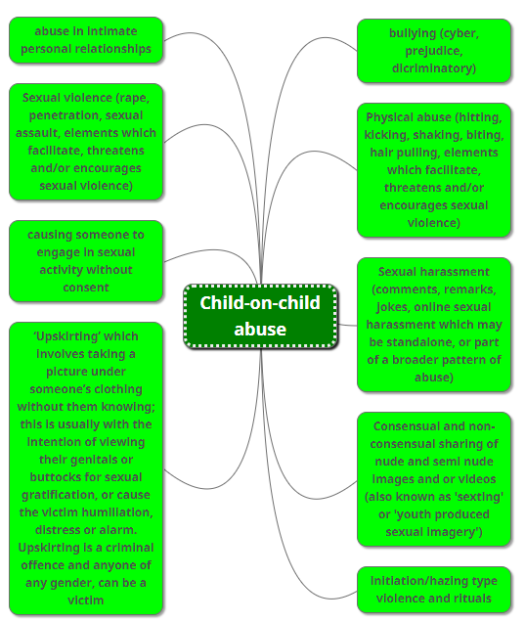

# Bullying

Bullying

Bullying is defined as the repetitive, intentional harming of one person or group by another person or group, where the relationship involves an imbalance of power. Bullying is, therefore:

* Deliberately hurtful
* Repeated, often over a period of time
* Difficult to defend against

## Types of bullying

Please refer to our anti-bullying policy for more information.

Bullying can include:

|  |  |
| --- | --- |
| TYPE OF BULLYING | DEFINITION |
| Emotional | Being unfriendly, excluding, tormenting |
| Physical | Hitting, kicking, pushing, taking another’s belongings, any use of violence |
| Prejudice-based and discriminatory, including:   * Racial * Faith-based * Gendered (sexist) * Homophobic/biphobic * Transphobic * Disability-based | Taunts, gestures, graffiti or physical abuse focused on a particular characteristic (e.g., gender, race, sexuality) |
| Sexual | Explicit sexual remarks, display of sexual material, sexual gestures, unwanted physical attention, comments about sexual reputation or performance, or inappropriate touching |
| Direct or indirect verbal | Name-calling, sarcasm, spreading rumours, teasing |
| Cyber-bullying | Bullying that takes place online, such as through social networking sites, messaging apps or gaming sites |

# Confiscation, searches, screening

Searching, screening and confiscation is conducted in line with the DfE’s [latest guidance on searching, screening and confiscation](https://www.gov.uk/government/publications/searching-screening-and-confiscation). Parents will be informed of any confiscation or searches.

## Confiscation

Any prohibited items found in a pupil’s possession as a result of a search will be confiscated.

## Prohibited items:

* Knives or weapons
* Alcohol
* Illegal drugs
* Stolen items
* Tobacco and cigarette papers
* Fireworks
* Energy drinks
* Vapes
* Pornographic images
* Any article a staff member reasonably suspects has been, or is likely to be, used to commit an offence, or to cause personal injury to, or damage to the property of, any person (including the pupil)

Searching a pupil and their possessions

Searches will only be carried out by a member of staff who has been authorised to do so by the headteacher, or by the headteacher themselves. Please see the following guidance for more information.

A pupil’s possessions can be searched for any item if the pupil agrees to the search. If the pupil does not agree to the search, staff can still carry out a search for prohibited items. An authorised member of staff can search a pupil’s possessions when the pupil and another member of staff are present. We follow the following guidance: <https://www.gov.uk/government/publications/searching-screening-and-confiscation>

**TEAM TEACH**

Team Teach – Restraint

Reasonable force covers a range of interventions that involve physical contact with pupils. All members of staff have a duty to use reasonable force, in the following circumstances, to prevent a pupil from:

* Causing disorder
* Hurting themselves or others
* Damaging property

Detailed advice is available in:

[**https://www.gov.uk/government/publications/use-of-reasonable-force-in-schools**](https://www.gov.uk/government/publications/use-of-reasonable-force-in-schools)[**https://www.teamteach.co.uk/**](https://www.teamteach.co.uk/)

# Transition of pupils

Pupil Transition

The school will support incoming pupils to meet behaviour standards by offering an induction process to familiarise them with the behaviour policy and the wider school culture.

Preparing outgoing pupils for transition

To ensure a smooth transition to the next year, pupils have transition sessions with their new teacher(s). In addition, staff members hold transition meetings.

To ensure behaviour is continually monitored and the right support is in place, information related to pupil behaviour issues may be transferred to relevant staff at the start of the term or year.

The policy is reviewed annually.

# Appendix 1: ClassDojo and communication

ClassDojo and House Points

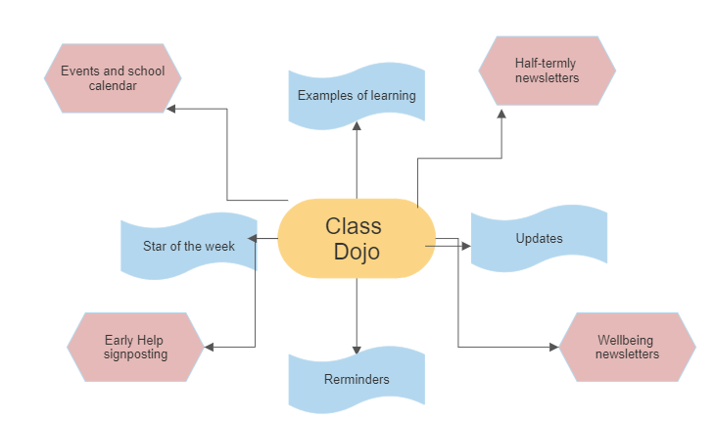

# Appendix 2: Playtime and Lunchtime Procedures

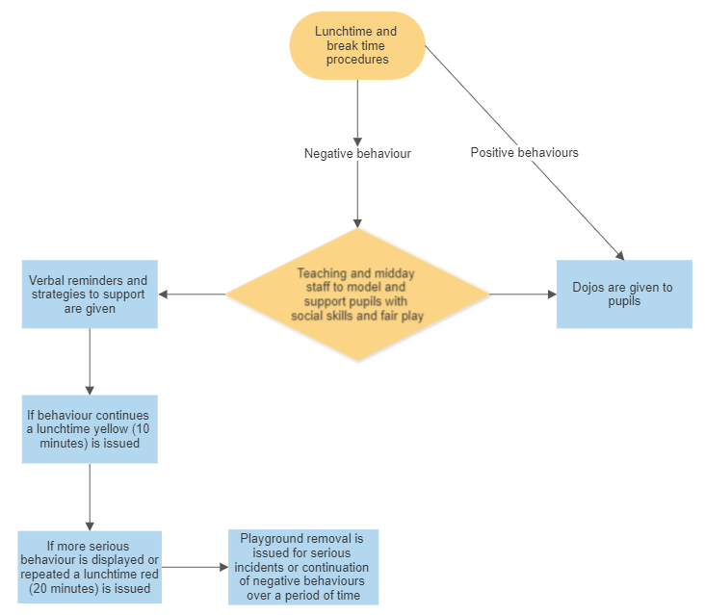

More Serious Behaviour Incidents

The following behaviours will be dealt with in a more formal way:

* Fighting
* Bullying (physical and verbal)
* Racial or sexual abuse
* Vandalism
* Theft
* Verbal/physical assault on adults

# Appendix 4: Behaviour for Learning

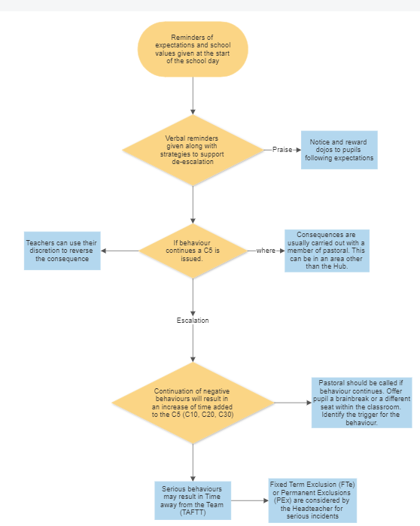

Zone Diaries and Trackers

### Appendix 4a: Zone Diary example

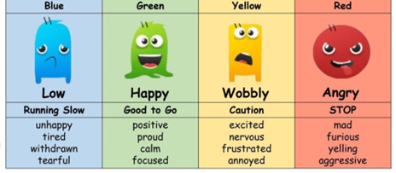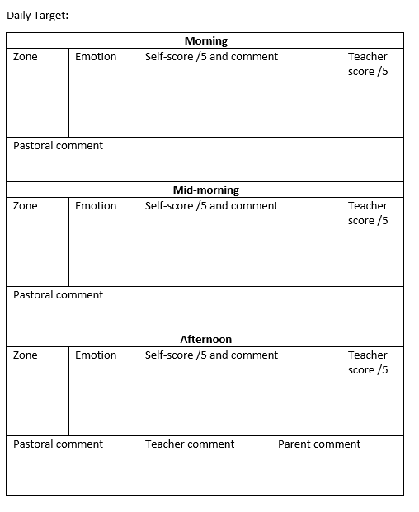

### Appendix 4b: Example tracker

