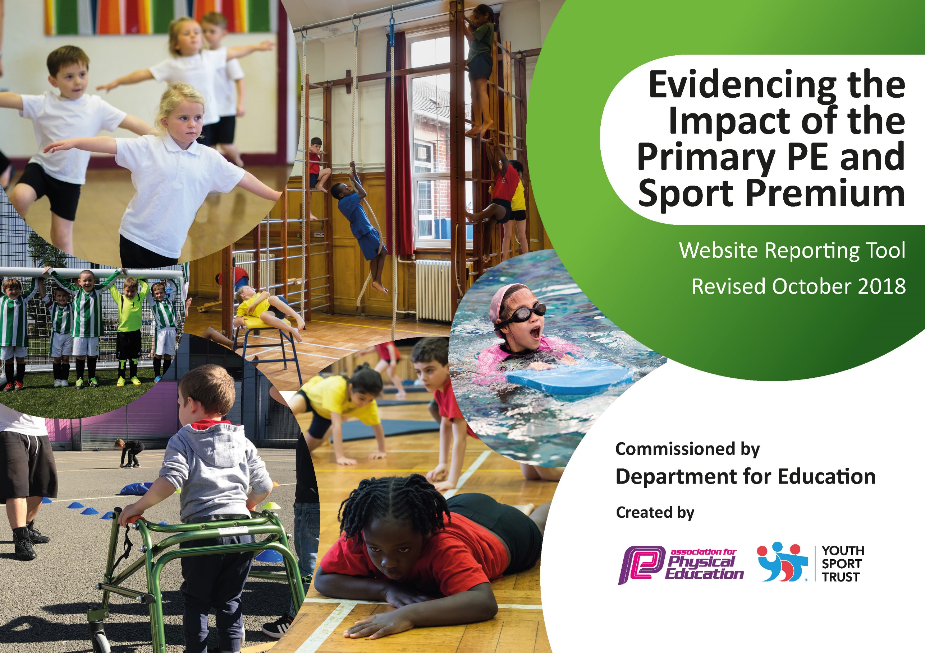
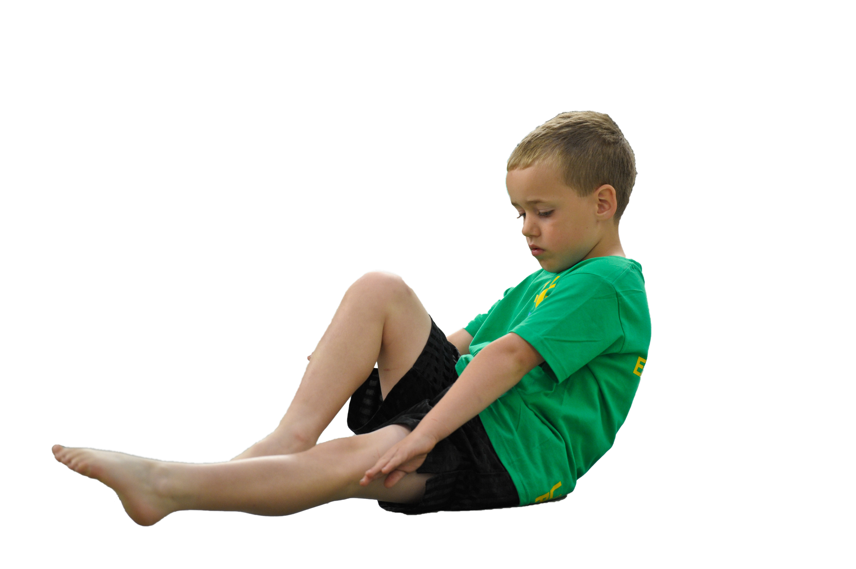
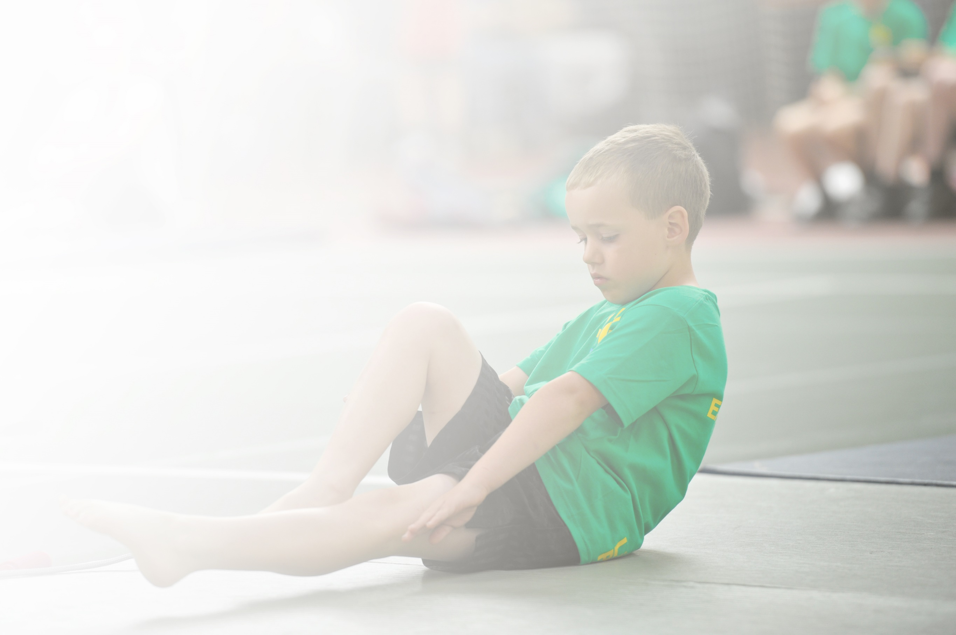
Schools must use the funding to make additional and sustainable improvements to the quality of Physical Education, Sport and Physical Activity (PESPA) they offer. This means that you should use the Primary PE and Sport Premium to:

- Develop or add to the PESPA activities that your school already offer
- Build capacity and capability within the school to ensure that improvements made now will benefit pupils joining the school in future years

Please visit gov.uk for the revised DfE guidance including the 5 key indicators across which schools should demonstrate an improvement. This document will help you to review your provision and to report
your spend. DfE encourages schools to use this template as an effective way of meeting the reporting requirements of the Primary PE and Sport Premium.

We recommend you start by reflecting on the impact of current provision and reviewing the previous
spend. Under the Ofsted Schools Inspection Framework, inspectors will assess how effectively leaders use the Primary PE and Sport Premium and measure its impact on outcomes for pupils, and how effectively governors hold them to account for this.

Schools are required to publish details of how they spend this funding as well as on the impact it has on pupils’ PE and sport participation and attainment by the end of the summer term or by 31 July 2019 at the
latest.
We recommend regularly updating the table and publishing it
on your website throughout the year, as evidence of your
ongoing review into how you are using the money to
secure maximum, sustainable impact. To see an
example of how to complete the table please
click HERE.

Support for review and reflection - considering the 5 key indicators from DfE, what development needs are a priority for your setting and your students now and why? Use the space below to reflect on previous spend, identify current need and priorities for the future.

Key achievements to date: | Areas for further improvement and baseline evidence of need:
- Children are now more active at lunchtimes and break times due to sports coaches being employed to work at this time.  - Encourage healthier packed lunches as part of a drive to improve overall lifestyle choices.  - Cooking club to inform children of how to cook healthy meals.  - Sports competitions (intra and inter school) are beginning to take place.  - Identify focus areas for further teacher CPD.  - Identify non-swimmers earlier in their school life and provide top up swimming lessons to ensure they meet national curriculum standards. | - Create opportunities for competitive sports fixtures with local schools.  - Consider how we might introduce additional whole school activities e.g.  - Ensure all groups of children are targeted at lunchtimes for extra physical activity and record this information.  - CPD to address focus areas.

Meeting national curriculum requirements for swimming and water safety | Please complete all of the below:
What percentage of your current Year 6 cohort swim competently, confidently and proficiently over a distance of at least 25 metres?  N.B. Even though your children may swim in another year please report on their attainment on leaving  primary school. | No data due to Covid-19- Priority given to year 3 as they had no water experience.
What percentage of your current Year 6 cohort use a range of strokes effectively [for example, front crawl, backstroke and breaststroke]? | No data due to Covid-19- Priority given to year 3 as they had no water experience.
What percentage of your current Year 6 cohort perform safe self-rescue in different water-based situations? | No data due to Covid-19- Priority given to year 3 as they had no water experience.
Schools can choose to use the Primary PE and Sport Premium to provide additional provision for swimming but this must be for activity over and above the national curriculum requirements. Have you used it in this way? | Yes/No

Action Plan and Budget Tracking
Capture your intended annual spend against the 5 key indicators. Clarify the success criteria and evidence of impact that you intend to measure to evaluate for students today and for the future.

Academic Year: 2021/2022 | Total fund allocated: £19,600 | Date Updated: 20th May
Key indicator 1: The engagement of all pupils in regular physical activity – Chief Medical Officer guidelines recommend that primary school children undertake at least 30 minutes of physical activity a day in school |  |  |  | Percentage of total allocation:
 |  |  |  | %
School focus with clarity on intended impact on pupils: | Actions to achieve: | Funding allocated: £8822.50 | Evidence and impact: | Sustainability and suggested next steps:
Ensure more children are taking part in more focused physical activity during break and lunchtimes.  Create house group competitions at lunch times to engage children in competitive sports. | Zones to be marked out in the playground for competitions to take place. (Summer 1, due to staff absences)  - Relaunch house groups (Autumn 1)  - CPD for all staff- How the house competitions will run. (Spring 2)  - Power point made to share with children about launch of competitions. (Spring 2)  - Sports coaches to run competitions  (Spring 2) |  | Zones have been marked on playgrounds, this has enabled staff to ensure children are playing a range of sports at break and lunchtime in designated zones, allowing also for quitter areas of the playground.  - House groups have been relaunched successfully to incorporate the learning strands of our school) by PE lead.  - CPD shared in summer 1 (due to staff absences) -allowing all staff to understand how the competitions will run and how the zones should be used.  - Power point shared with all children in assembly by CW. (summer 1)  - Sports coaches will run lunchtime competitions from start of Summer 1. | Ensure there is a rota of activities and sports in the zones to keep children engaged and give opportunities to try out different or new games.  Continue to make house group competitions high profile in school by having regular competitions in sport and other areas of school life.
Key indicator 2: The profile of PESSPA being raised across the school as a tool for whole school improvement |  |  |  | Percentage of total allocation:
 |  |  |  | %
School focus with clarity on intended impact on pupils: | Actions to achieve: | Funding allocated: £3497.50 | Evidence and impact: | Sustainability and suggested next steps:
Gardening club  Healthy cooking club  Healthy lunchbox work.  By having more sporting competitions happening within school, the PESSPA profile will be raised by celebrating success using house points.  This will also make children more aware of the Spirit of Sport values (Honesty, Respect, Teamwork, Self-belief, Determination and passion) leading to improved behaviour around school. | Once after school clubs are running (Covid-19 dependant) JW to start these clubs again.  Sports competitions at lunch times as in key indicator 1.  Termly whole school competitions such as skipathon, football tournament and sports day.  Spirit of Sport – one child from each class is awarded spirit of sport each half term alongside gold book awards. |  | Gardening and cooking club have been able to run for one term – children are showing a greater understanding of how to eat healthily and grow vegetables from seed.  Skipathon in spring 2 (JW to organise), football tournament and sports day in summer 2 (PE lead to organise)  Teachers to choose a pupil each half term who have displayed the spirit of sport values. | Continue with this in 2021/22 to allow more children to benefit from this.  Try to include a competition for the autumn term also.

Key indicator 3: Increased confidence, knowledge and skills of all staff in teaching PE and sport |  |  |  | Percentage of total allocation:
 |  |  |  | %
School focus with clarity on intended  impact on pupils: | Actions to achieve: | Funding  allocated: £2000,00 | Evidence and impact: | Sustainability and suggested  next steps:
Staff survey to find areas that need development in teaching PE.  PE lead to team teach with teachers who are still lacking confidence in teaching PE.  PE lead to arrange training for all teachers. | Survey created and carried out in Autumn 2 by PE lead.  PE lead to be released from teaching duties to monitor and support class teachers.  Training in the area of differentiation, questioning and inclusion in PE. |  | From the survey it is clear that some teachers are lacking confidence with behaviour management techniques and assessment in PE.  CPD given in Spring 1 around assessment and structure of lesson plans.  New teachers invited to observe a model PE lesson with a focus on behaviour management (Autumn 2, PE lead)  Unable to complete due to staff absences.  Postponed due to staff absence. | Survey teachers again in summer 2 to gain insight into development areas for following year. (PE lead)  Possibly complete during summer term.  Book for Autumn 1 2022/2023.
Key indicator 4: Broader experience of a range of sports and activities offered to all pupils |  |  |  | Percentage of total allocation:
 |  |  |  | %
School focus with clarity on intended  impact on pupils: | Actions to achieve: | Funding  allocated: £3280.00 | Evidence and impact: | Sustainability and suggested  next steps:
Engage children in different sports by running a range of sports clubs at lunchtime, afterschool and in school holidays.  Due to many year 3 children having never experienced swimming due to the Covid-19 lockdowns. An extra term of swimming has been allocated for year 3 children to swim. | Teachers/sports coaches to run a range of sports clubs.  Sports coaches to run holiday clubs  Extra time booked with the swimming pool. |  | No impact yet due to staff absences  Holiday club begins in summer 2021/2022. | Teachers with interests in different clubs to run taster sessions or clubs throughout summer/autumn term.
Key indicator 5: Increased participation in competitive sport |  |  |  | Percentage of total allocation:
 |  |  |  | %
School focus with clarity on intended  impact on pupils: | Actions to achieve: | Funding  allocated: £2000.00 | Evidence and impact: | Sustainability and suggested  next steps:
Lunchtime competitions to begin in summer 1 see key indicator 1.  Create connections with local schools to begin running competitions | Sports coaches to run lunchtime competitions.  PE lead to organise some competitions with local schools. We will host events to ease on staffing pressures. (summer term). |  | Children are now more active and competing in sporting competitions. | Continue in 2022/2023  Football and netball competitions organised for summer 2 with a local school.

